Programming projects laboratory

Students Marks application 2 WPF

Bernat Galmés Rubert

2016-2017

# User manual:

## Executing the code:

## Main menu screen:

When you have executed the program, you will see the next window:

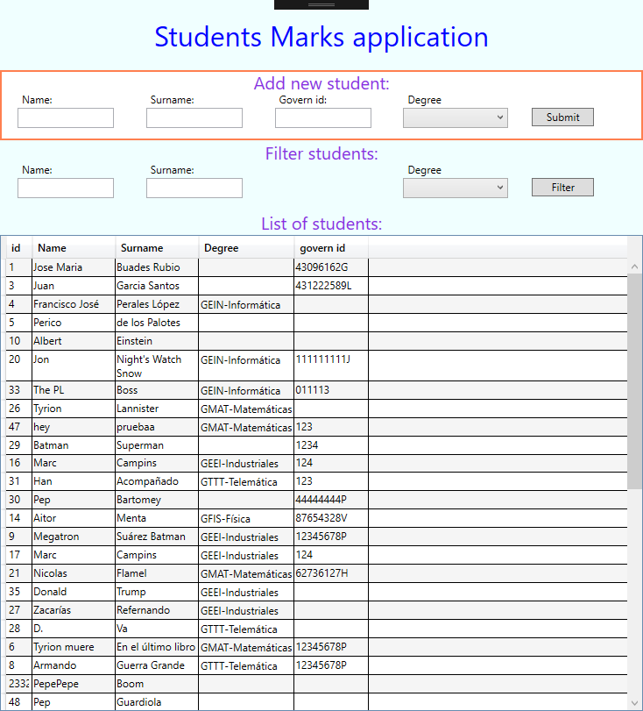

As you can see the application is splitted in three parts:

1. A Form to insert new students. (Form inside orange square)
2. A form to filter the data that is shown in the datagrid of the third part.
3. A datagrid with all the data that contains the database.

## Insert new student:

To insert a new student in the database you only have to fill the first form with the data of the new student. To select an empty degree you can two options: select the option ‘no degree’ or leave the field empty.

## Filter list:

To filter the students that are showed in the datagrid, you must use the form that is onto the datagrid.

### Filtering name:

If you fill their corresponding field, when you press the button filter the datagrid is updated. And you will only see the students that his name contains the substring that you have introduced.

### Filtering surname:

It works like the name filtering.

### Filtering by degree:

After clicking botton filter:

* If you haven’t selected any degree the field is ignored.
* If you have selected a degree the datagrid only will show the students that are related with this degree
* If you select the option ‘no degree’ the app will show only the students no related with any degree.

### Filtering fields together

When you press the button filter at the right of the form, the three fields are filtered together. The empty fields are ignored. And are showed in the datagrid the fields that are not filtered by any field.

## Modify data:

If you want to modify data from the datagrid, you can edit directly the fields in the datagrid. When you press the enter key, the register is updated in the database.

To assign an empty degree you must select the option ‘no degree’.

# Conclusions:

This practice could have been very easy, if it had been done with a single form for insert and update.

The most difficult aspect has been developing the datagrid in the way that you can edit this, and the database is updated at the same time. Discover how it works is not trivial, there is not all the information in the same documentation page. And is not very clear in any part how to take the new information introduced in a cell, using the event that is raised when a cell editing finish.